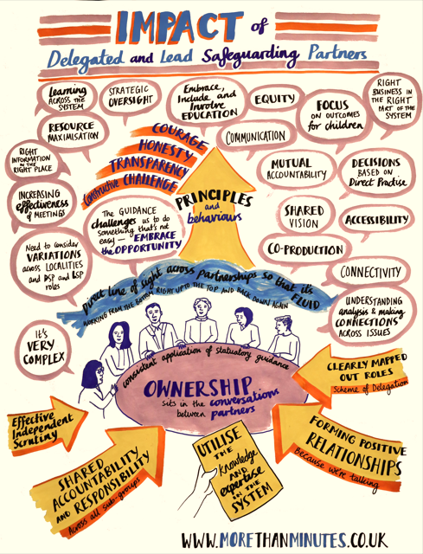

A national child safeguarding practice review has investigated the experience of 193 children who were sexually abused by a family member: [National review into child sexual abuse within the family environment - GOV.UK](https://www.gov.uk/government/publications/national-review-into-child-sexual-abuse-within-the-family-environment) The report reveals that safeguarding agencies were not equipped with the skills and support to listen, hear and protect these children from horrific abuse.

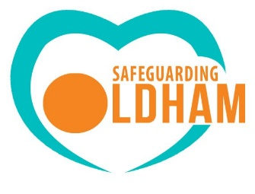The North West Regional Improvement Pilot Programme (RIPP) are delivering multi-agency training to support the implementation of the pathway and resources in the NW free of charge.

Free training webinars

Introduction to the CSA Response Pathway – 27th February 2025

(10am – 11.30am)

Join us for an informative online session where we will delve into the **Child Sexual Abuse Response Pathway** in the North West region. Learn about the steps involved in responding to child sexual abuse cases and the resources available to support victims, children and families.

Further information and to book a place – click [**here**](https://www.eventbrite.co.uk/e/introduction-to-the-child-sexual-abuse-response-pathway-north-west-tickets-1203461869849?aff=oddtdtcreator)

The Response Pathway – 28th April **or** 13th May 2025

(1pm – 2pm **or** 10am – 11am)

This one-hourwebinar will help professionals learn how to start using the [Child Sexual Abuse Response Pathway | CSA Centre](https://www.csacentre.org.uk/child-sexual-abuse-response-pathway/) in practice, and empower them to understand the role they, and their colleagues, can play to best protect and support children. The session gives advice and examples of how to use the Response Pathway and explains how it supports professionals to meet the needs of children and their families.

To book onto the 28th April 2025 session, click [**here**](https://www.eventbrite.co.uk/e/child-sexual-abuse-the-response-pathway-webinar-tickets-1220668645779?aff=oddtdtcreator)

To book onto the 13th May 2025 session, click [**here**](https://www.eventbrite.co.uk/e/child-sexual-abuse-the-response-pathway-webinar-tickets-1223342914589?aff=oddtdtcreator)

Spotting the signs and indicators of child sexual abuse – 21st May **or** 10th June 2025

(9.30am – 10.20am **or** 10am – 11am)

This one-hour webinar will introduce professionals to the Signs and Indicators Template and give an opportunity to use it in practice. It aims to give professionals working with children the knowledge and confidence to act when they are concerned about a child.

Further information and to book a place on 21st May – click [**here**](https://www.eventbrite.co.uk/e/spotting-the-signs-and-indicators-of-child-sexual-abuse-webinar-tickets-1223370507119?aff=oddtdtcreator)

To book onto 10th June 2025 session – click [**here**](https://www.eventbrite.co.uk/e/spotting-the-signs-and-indicators-of-child-sexual-abuse-webinar-tickets-1223729751629?aff=oddtdtcreator)

Communicating with children about sexual abuse – 11th June **or** 7th July 2025

(10am – 11am **or** 10.30am – 11.30am)

This one-hour webinar aims to help professionals understand what they can do to help children by putting our [Communicating-with-children-guide.pdf](https://www.csacentre.org.uk/app/uploads/2023/09/Communicating-with-children-guide.pdf) into practice. In this session we will explain what may be going on for children when they are being sexually abused, what prevents them from talking about their abuse, and what professionals can do to help children speak about what is happening.

For more information and to book a place for 11th June session – click [**here**](https://www.eventbrite.co.uk/e/speaking-with-children-about-child-sexual-abuse-webinar-tickets-1223741637179?aff=oddtdtcreator)

To book onto 7th July session – click [**here**](https://www.eventbrite.co.uk/e/speaking-with-children-about-child-sexual-abuse-webinar-tickets-1223749460579?aff=oddtdtcreator)

Supporting parents and carers when their child has been sexually abused – 15th July **or** 9th September 2025

(10.30am – 11.30am)

This one-hour webinar aims to help professionals understand what they can do to support parents / carers by putting our [Supporting parents and carers guide](https://www.csacentre.org.uk/research-resources/practice-resources/supporting-parents-and-carers/) into practice. This webinar hopes to guide your thinking in supporting parents and carers of any age, including those with special education needs.

To book onto 15th July session – click [**here**](https://www.eventbrite.co.uk/e/supporting-parentscarers-when-their-child-may-have-been-sexually-abused-tickets-1223760192679?aff=oddtdtcreator)

To book onto 9th September session – click [**here**](https://www.eventbrite.co.uk/e/supporting-parentscarers-when-their-child-may-have-been-sexually-abused-tickets-1223764124439?aff=oddtdtcreator)

Responding to harmful sexual behaviour in education settings – 8th July or 15th September 2025

(4pm – 5pm)

This one-hour webinar aims to help give professionals the knowledge and confidence to act, using the CSA Centre’s [Safety planning in education: A guide for professionals supporting children following incidents of harmful sexual behaviour](https://www.csacentre.org.uk/app/uploads/2023/09/Safety-Planning-in-Education.pdf). This guide supports your thinking in supporting children of any age, including those with special education needs, following incidents of harmful sexual behaviour.

To book onto 8th July session – click [**here**](https://www.eventbrite.co.uk/e/responding-to-harmful-sexual-behaviour-in-education-settings-webinar-tickets-1223767945869?aff=oddtdtcreator)

To book onto 15th September session – click [**here**](https://www.eventbrite.co.uk/e/responding-to-harmful-sexual-behaviour-in-education-settings-webinar-tickets-1223774054139?aff=oddtdtcreator)