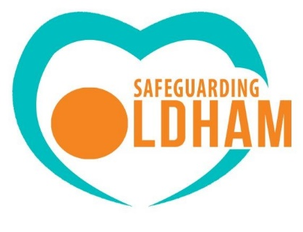
OSCP Training Report 2023/24

What are we doing?
Safeguarding children effectively requires a knowledgeable and skilled workforce. By delivering multi agency training Oldham Safeguarding Children Partnership aims to provide staff with good quality training that enhances inter agency communication, cooperation and provides a place to reflect on practice. New research, legislation and guidance and local learning means that there is a continuous demand to update members of the workforce. An effective means to achieve this is using skilled and experienced practitioners who can share their knowledge and expertise. The training programme continues to be closely linked to the priority safeguarding concerns identified in the partnership annual business plan.

Who is doing this?
The training pool continues to be the core delivery system for training which enables us to be Oldham centric in our work, all evaluation forms tend to reference the benefit of receiving local knowledge from local staff/services. We have devised a comprehensive person specification for training pool members and offer a train the trainer course to all our pool members. We are in the process of reviewing training courses and recruiting to the training pool.
Delivery System
- Classroom based learning.
- e-learning
- Webinars
- Briefings
- Audits and workshops
- Newsletter
- Quarterly safeguarding training spotlight
- Conferences
- 7-minute briefings
- OSCP twitter
- OSCP website
- Seriously good case reviews
- Monitoring and evaluation of impact

Commissioned Training and associated costs so far:
- Greater Manchester Immigration Aid Unit - No recourse to public funds £200.
- Cornerstone Training and Support Ltd – Safeguarding children from sexual abuse £625.
- LPS Law - Cop Dols £2000.
- Calder Training and Consultancy Limited - Safeguarding children with disabilities £850.

Attendance so far - Over 2023-2024 there were 50 training opportunities with 1,025 attendees from across the partnership accessing a variety of blended learning approaches including face to face classroom-based, online based, briefings and webinars.
Training Safeguarding Spotlight - We have retained the quarterly training offer (safeguarding spotlight) in place of an annual plan as this enables up to be flexible to any emerging needs or trends as identified via Safeguarding Reviews and the Strategic Learning Hub.
White Ribbon. Conference for young people - 29 November 2023
Oldham is now White Ribbon Accredited. As part of our White Ribbon two weeks of action, Oldham Council, Youth Council and Safeguarding Children Partnership invited local schools to attend our, Me, Myself, and I Conference. This work forms parts of the council’s efforts to raise awareness of the White Ribbon campaign and aims to prevent violence against women and girls.
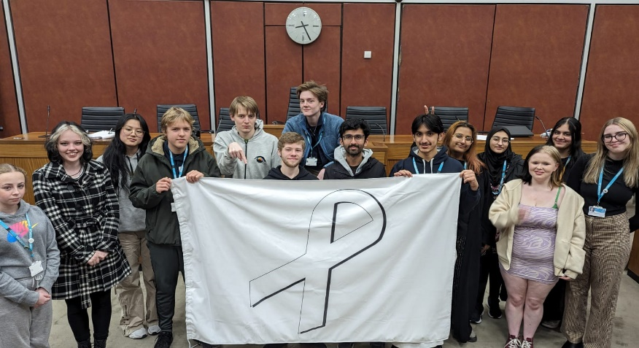
67 year 9 pupils from 11 schools attended.
This Conference provided young people with the opportunity to watch a performance piece which focused on the self and how our values, attitudes and behaviours are influenced. It explored both positive and negative narratives, and behaviours which may to lead things such as domestic abuse, harmful attitudes and social norms that contribute to gender inequality.
https://www.whiteribbon.org.uk/children-and-youth
https://www.whiteribbon.org.uk/news/2023/12/14/oldham-council-holds-me-myself-and-i-conference-with-local-schools-to-changethestory
The workshops
Equality Street – How messages about masculinity and femininity can shape our views and actions.
Fact v Fantasy – The rise of the influencer, information, and disinformation.
Relationship Red Flags – Expecting respect.
What’s love got to do with it- The clash between culture and consent.

Website
Our website had been redesigned a new safeguarding topics facility will enable us to house a variety of information including videos from professionals that will enhance learning, this includes.
ABCs of Trauma – facilitated by our local CAMHS team.
- ACES / Attachment
- How trauma can affect behaviour
- Communicating with distress children (PACE model)
The ABCs will be a good precursor to accessing the free Aces and Trauma Home office e-learning module house on our website.
The Role of the HBV IDVA facilitated by our local HBVA Specialist complements the Home Office HBV e-learning module and provides a link into local specialism.
The GCP2 facilitated by the Training Consultant Provides an overview of the tool, and is mandatory watching for those attending our Neglect Matters Training (neglect foundation)
Our local e learning module has been reviewed; updates will be made via Oldham College who have facilitated the platform for us.
The Cut It Out campaign
Cut it out is a training initiative directed at hairdressers and the beauty economy that aims to raise awareness of domestic abuse. A bespoke training session for 23 students and apprentices was devised and rolled out at Oldham College this training year. Further sessions will take place later in the year.
Train the trainer domestic abuse - As an action from JTIA Panel Meeting (29.6.2022). The Training Consultant and Domestic Abuse Operational Manager have co-written a train the trainer domestic abuse foundation course. This is offered to all partnership members, the aim being there is a consistent baseline foundation offer that single agencies can use in their organisation as required. We continue to offer this training which has reached over 100 staff within single agencies. We aim to train IDVAs within the LA to be able to run this offer to reach more staff.
Graded Care Profile 2 (GCP2)
In 2022 – 2023 the partnership began to plan for the implementation of the Graded Care Profile 2 (GCP2). GCP2 is an assessment tool that helps practitioners take a strengths-based approach to measuring the quality of care a child is receiving and supports them to identify neglect.
In September 2023 the training roll out of the tool across Oldham Safeguarding Children Partnership agencies began. 104 staff have been trained in the GCP2. The Neglect Subgroup monitors activity in relation to GCP2 completions and impact.
A new foundation training course (neglect maters) has been developed and delivered a Neglect Advanced course is in the process of being written.

Training and Learning Network
The Training and Leaning Network is a newly established group that sits under the strategic learning hub. Its aim of the network is to bring together representatives from partner agencies reflected through the membership of the Strategic Learning Hub, whose remit is or includes training/workforce development.
Examples of how we evaluate.
Confidence questions in relation to safeguarding topics.
Pre and post course evaluations- linked to learning outcomes from subject matter.
Likert scales
Training pledges-re visited 3 months after training.
Deep dive evaluation 3 months after training, led by the network, where participants and managers are independently contacted regarding the impact of training in practice.
Microsoft forms
Support surgeries for projects and participants whom have attended train the trainer

Catherine Lawler
OSCP Training Consultant
July 2024

